The general rules of time series data includes times, dates and periods. Time gives an extra dimension or relevance to our analysis and measures are plotted against a time axis or an interval. The measurement could be applicable to a seasonal or a time specific (sales or traffic flow over time), growth, regression or forecasting.

We will discuss in here the best practices to visualize time series data and how to apply a time-series model in the production environment for project oriented environment.

In the below visualization, we can see the discrete field **Month (Date)** is dragged to the column field and **Sales** is dragged on the Rows field.

**Discrete variables** (blue colour) are generally a list of values or a defined amount of elements or string (names, categories, IDs) or numeric (a list of numerical values) or date (year, quarter, month or weekdays). The number of elements is finite.

**Continuous variables** (green) contain a range of values, such as

* A range of numerical values with all the desired steps possible between those values for an example {1…10}.
* Date or time – a range of date/time values between oldest to current values { 01.01.1900 - 11.12.2000}

Discrete data can be chosen as part, sorted or reordered, can draw headers but can skip elements such as data for a missing month.

The continuous fields draw axis with values, show all the potential elements but cannot be sorted or reordered.

In the below chart, each month header depicts the discrete variable while sales performance to each month is a continuous variable.

You need to make a note that continuous variables can be changed and used as discrete fields or continuous fields and in some cases, this is applicable for some dimensions such as dates.

The Month (Date) field has a hierarchy which is automatically organized such as year, month, quarter, weekly or daily. Hierarchies help the user to analyze the data from the granular level.

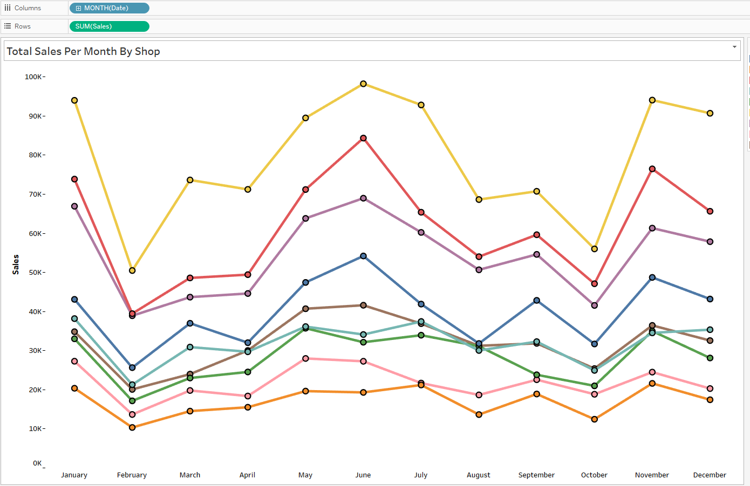

We can add an additional chart to see the percentage of sales value performance relative to the **previous day** of the month. We can see a downward trend from the below chart (percentage of differences in running total against the each day). The sales growth percentage goes down from the beginning of each month to the end. 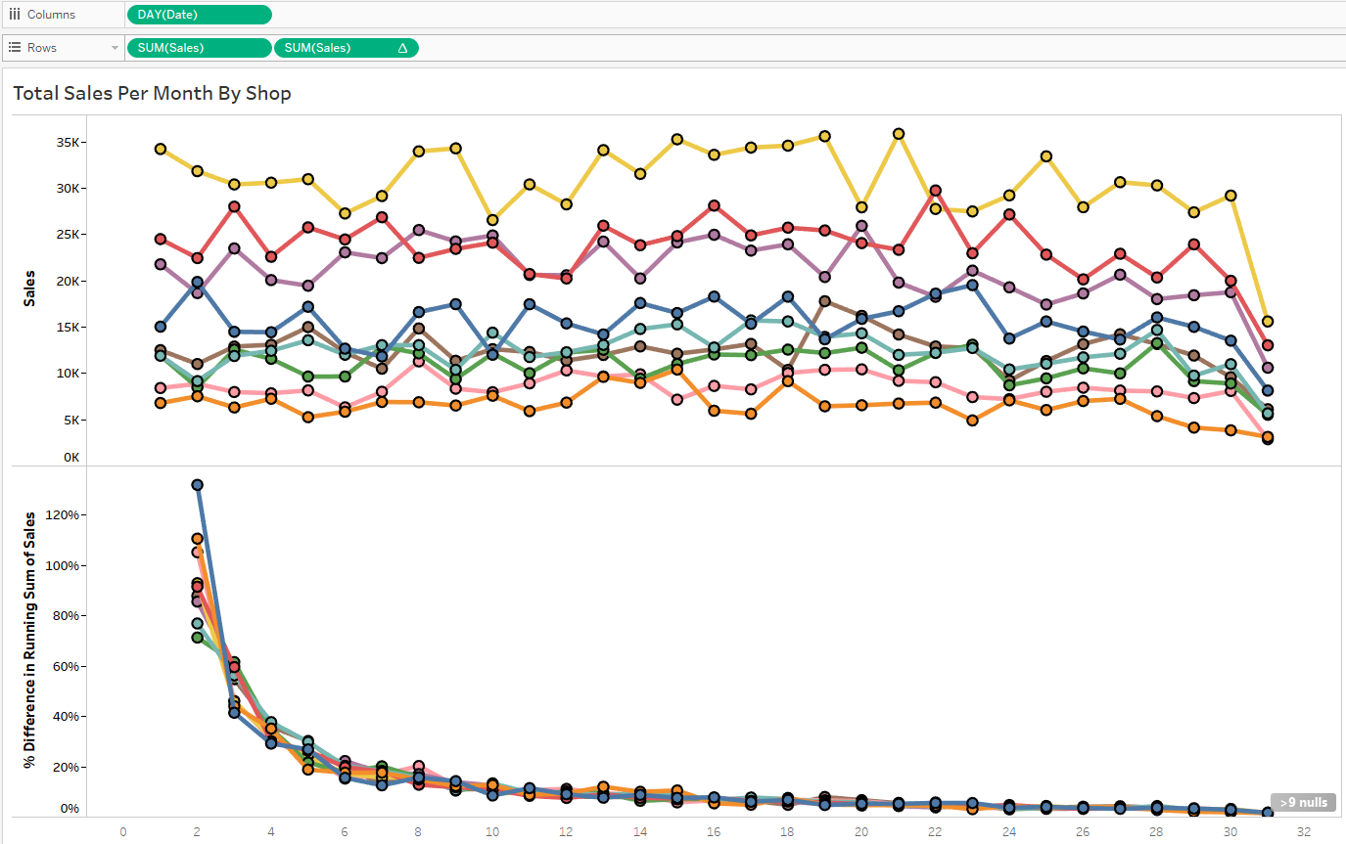

In the below chart, we have done coloration to make the percentage differences in more visible. The more thicker the line, the heavier the gain or loss.

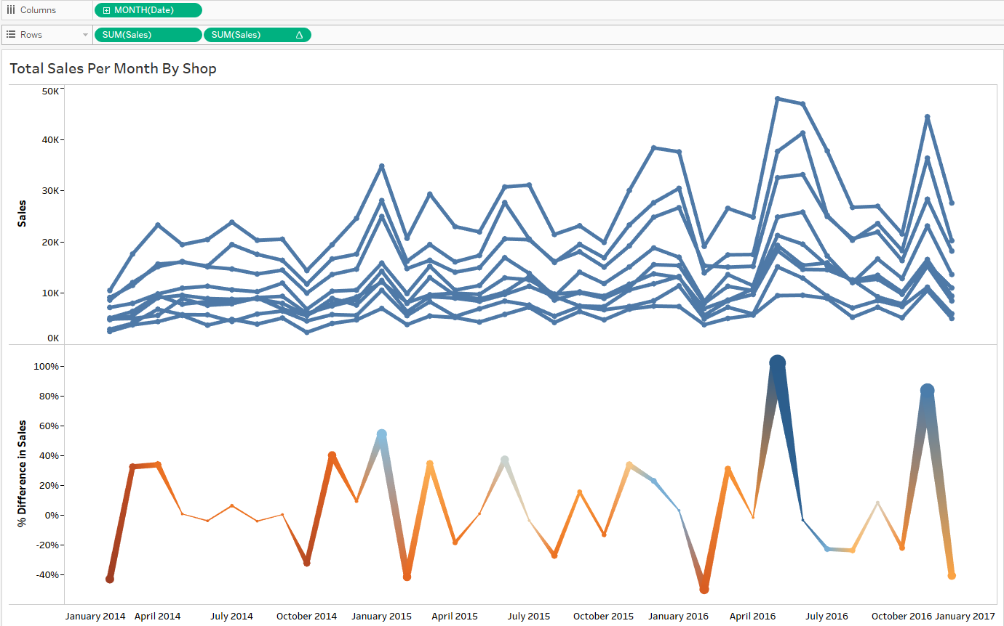

We will now create a visualization using time series data. We will also apply moving average calculation tables with some parameters. Moving average (MA) is widely used in finance and statistics. MA helps to smooth out the fluctuations in the available data, calculating an average, based on the given time parameter.

MA is a lagging indicator as it shows the past trend over time from the data of past events. As a rule of thumb, the bigger the window the smoother the line is on the visualization. For an example, 30 days MA is much smoother than 3 days MA.

The **Simple Moving Average** Formula:

**SMA = (*na*1​+*a*2​+…+*an)* / nn**

a=average in period nn=number of time periods​

There is another type of MA which is exponential moving average (EMA) where the recent data is given more weighted. We will use in our example SMA as each data point is equally weighted.

In the below chart, we have created a dynamic calculation field rather than changing the number of intervals each time on the table calculation field. The below parametric control gives us the leverage to quickly change ( slide down) to the desired intervals to see the moving average.

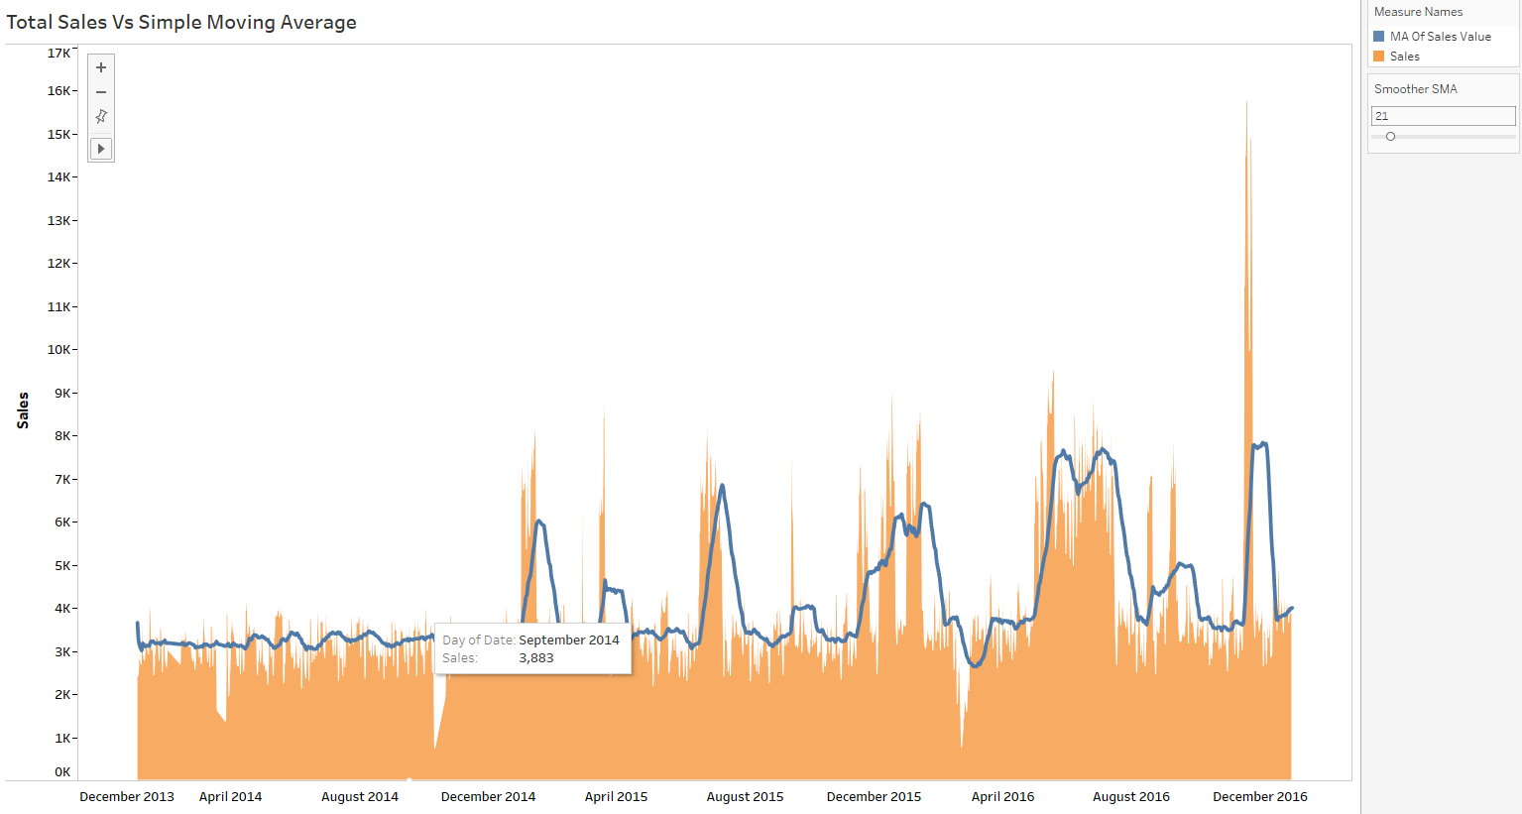

The below chart shows 183 days (six months) moving average on the same data. You can clearly see the noise is more smoothed in the below chart compared to the moving average with 21 days on the above chart.

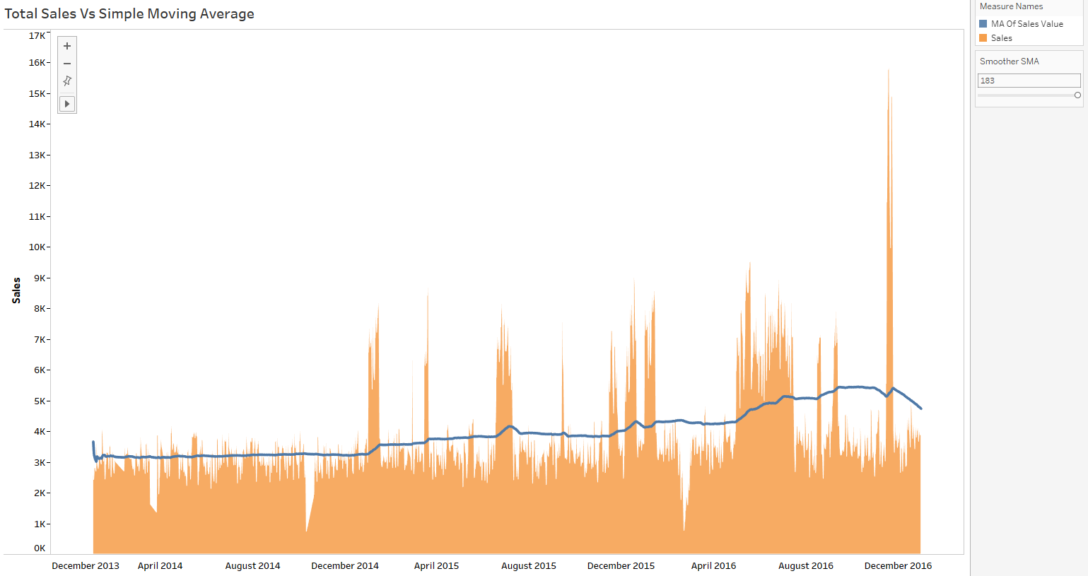

In the below visualization, we have created a sales forecast from the beginning date to the end date. You can change the date parameter through a reference line (the vertical dash line) which shows the beginning date from which you can chose to apply the forecasting technique up to the end date.

The blue line is the running total of the sales value and the orange line shows the forecasted value throughout the time intervals. The below sales forecasting parameter vale ranges from -1 to +1, with 5% interval. Therefore, we will be able to see the both positive and negative forecasted values against the actual sales value in various scenarios.

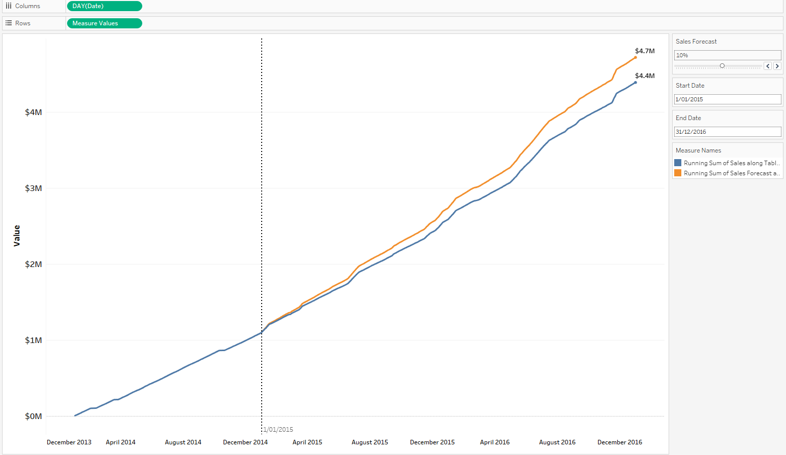

**Times series** data is used for the prediction of future events based on the pattern of past events. The past and present data is generally used to identify for the future pattern. More close the present data; the prediction will be more accurate. The further the future prediction goes, the broader the confidence level becomes. You need to have more data from the past and the present to build a more accurate model.

Trend and seasonality are well known forecasting techniques are widely used. Trend is a direction (upward or downward) based on the data. For an example, during bull market, the stock prices go up. If you find from your analysis that the price is moving upwards over the last five to six months, then you can see the basic trend is upward.

Generally, five to six observations are required for building a basic trend model.

Seasonality is pattern that repeats itself over a given time span. For an example, the temperature during the summer goes up or daily commercial parking occupancy rate during office hours. For identifying seasonal patterns, you need at least two seasonal cycles. Therefore, seasonal forecasting model could be bit expensive as you need to collect data for last two seasons to identify the pattern. You need to keep in mind that the time span is an aggregation of data values which could be year, quarter, month or day.

You can use **additive model** where the components are summed up and the amplitude of the seasonal effect is the same throughout the same year. For a monthly data, the difference between the January and June values is approximately the same each year. The model also assumes that the residuals are roughly the same throughout the series as they are the random components adds to the other components in the same way all parts of the series.

Data = Seasonal effect + Trend + Cyclical + Residual

In the **multiplicative model**, a season (January) is valued more than the other season (June) value. For an example, if the production in the January goes high and June production goes down due to lower market demand, you cannot assume that the difference is constant. The assumption is this model, the seasonal and other effects act proportionately on the data series.

Data = Seasonal effect * Trend * Cyclical * Residual

Multiplicative model can also be fitted as additive model, just taking logarithm on the both sides of the model

log(Data) = log(Seasonal effect * Trend * Cyclical * Residual)

= log(Seasonal effect) + log(Trend) + log(Cyclical) + log(Residual)

The data you need one dimension and one date dimension or one measure and one integer dimension. The dimension provides a specific order for the measure such as date dimension which works best with clear order. An integer dimension (IDs) is also works if it has a clear order against the measure values.

The below example is a seasonal additive forecasting model where we have fifteen year of weather temperature data. Tableau has an inbuilt forecasting model (exponential) which automatically did the forecasting for the next thirteen months ignoring the last one month. The prediction interval is chosen 90% in this example. You can exclude more than one data point or you can select zero data exclusion to avoid valuable information loss if you have very limited data.

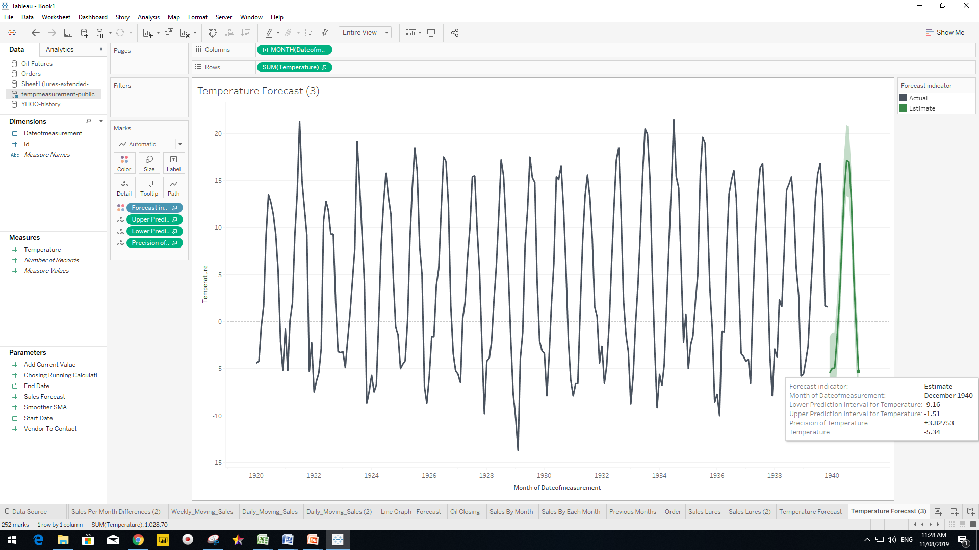

The summary data shows that this forecasting model did not find any trend at all, however 100% seasonal impact is noticed. The quality of the forecasting is ok but not good. The multiplicative model does not work in this dataset as there are negative values (temperatures) exist. Therefore, the additive model is the only option as it has the seasonal impact.

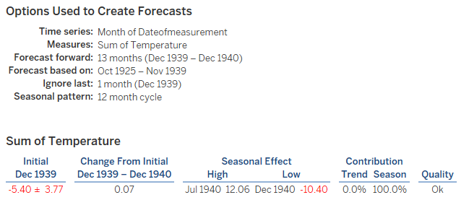

Now we will look into the forecasting model’s statistical analysis. The smoothing coefficients (Holt-Winters model) tell us whether a model relies heavily on recent data.

The alpha (shows how the recent values are given weight in the model) is zero that means the data is weighted uniformly rather than recent values are given more weight.

The beta (shows the trend value) is zero. It means that there is no trend. The beta determines the degree to which recent data trends are given value compared to the older trend during the forecast.

The gamma (shows the seasonality component) which is roughly 18%. The higher the parameter, the more the recent seasonal component is weighted. If the higher gamma value is used, that means the more recent seasonal pattern is emphasized over the less recent. We can see from the below gamma outcome that the uniform seasonal component is being applied by this model.

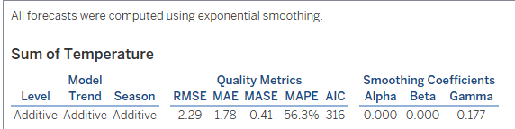

Root mean squared error: RMSE=√mean(e2t)

Mean absolute error: MAE= mean(|et|)

RMSE and MAE calculate the difference between the corresponding observation and the forecasted value. MAE is a linear score which means that all the individual differences are weighted equally in the average. In RMSE, the each corresponding observation and the forecasted value is initially squared and then averaged over the sample. RMSE is usually useful when there are less undesirable large errors. RMSE and MAE can range from 0 to ∞. They are actually negatively oriented scores. The lower the value is better for the model.

The above model shows that there is some variation in the magnitude of the errors. There are no very large errors occurred and the average difference between the observed and forecasted temperature is 1.78 degrees.

Mean absolute percentage error: MAPE = mean(|pt|)

MAPE measures the difference of the forecast errors and divides by the actual observation value, it penalizes negative value, gives more weight on the positive values.

The mean absolute scaled error: MASE = mean(|qj|)

MASE measures the difference of the forecast errors compared to the error of a naïve one-step forecast. The desired value should be less than one. The scaled error is less than one if it arises from the better forecast.

Akaike’s Information Criterion (AIC) is useful for selecting predictors for regression, useful for determining the order of an autoregressive integrated moving average (ARIMA) model. AIC penalizes the complex model.

AIC = 2k − 2 log(LML)

The first part o the equation is 2k which increases as we increase the parameter of our model. The complex model will get penalized. The second part is -2 log(LML) decreases as our model gets better data. It rewards us if the data fits in the model well.

In the below example, we have built an additive trend with multiplicative seasonal component. We have forecasted for the next three years of expected number of air passengers to fly.

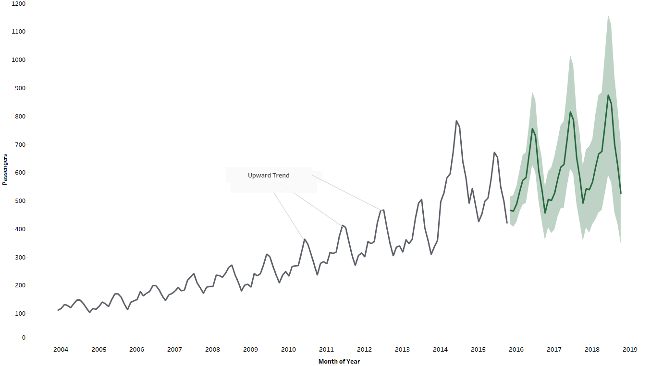

The model outcome:

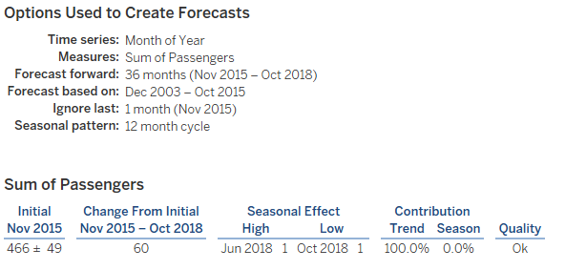

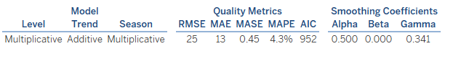

There is some limitation such as only exponential moving average is inbuilt with tableau. The other types of forecasting models are not possible such as ARIMA (Autoregressive Integrated Moving Average) with Tableau. ARIMA is most well recognized recently.

R-add on package has ‘forecast’ has ARIMA modeling features. The **auto.arima( )** function automatically selects the best parameters. The forecast ( ) function makes easy to select the forecast window and create a further exponential smoothing model. EMA has some lacking sometimes to provide a meaningful forecast result for some types of time series data,

Integrating R with tableau gives more options, however there are some limitations in the model descriptions. R returns the numeric forecast values, does not return a general model description. To get the description, the model needs to be replicated in R and extract the description there.

We have created three different model- the top one is ARIMA model, the second one R forecasting and the bottom one the normal tableau forecasting. Once we can see the models forecast, we can chose the best model.

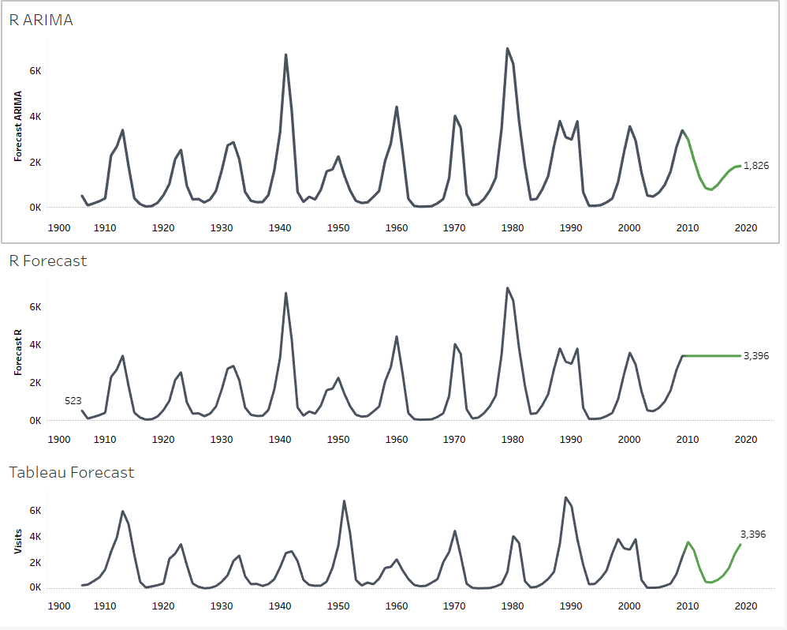

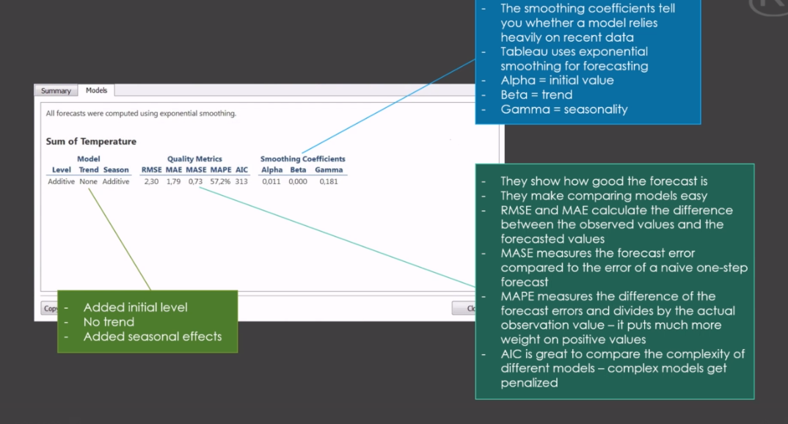

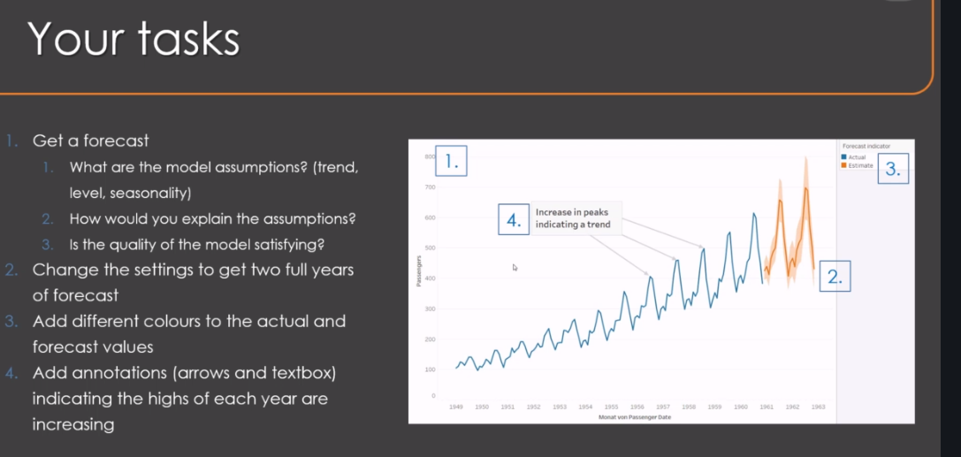

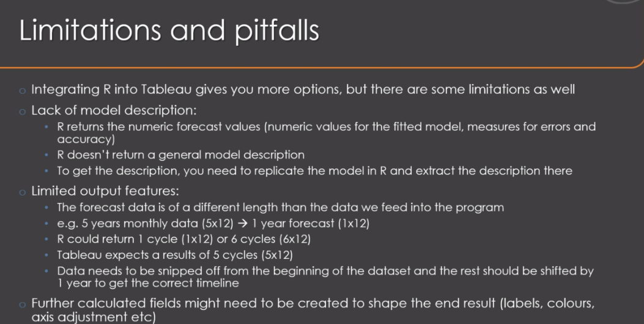

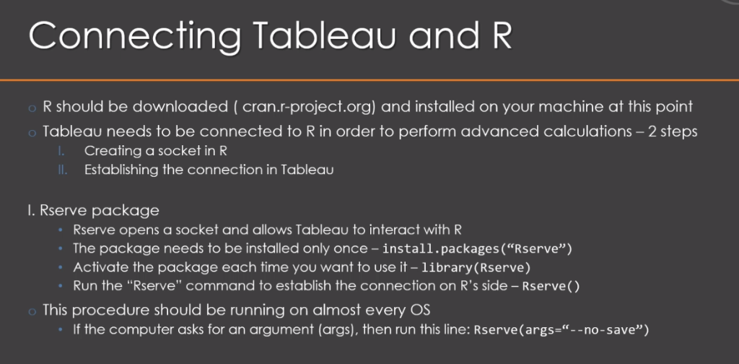

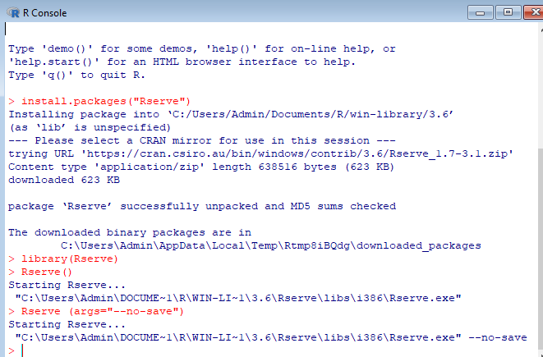

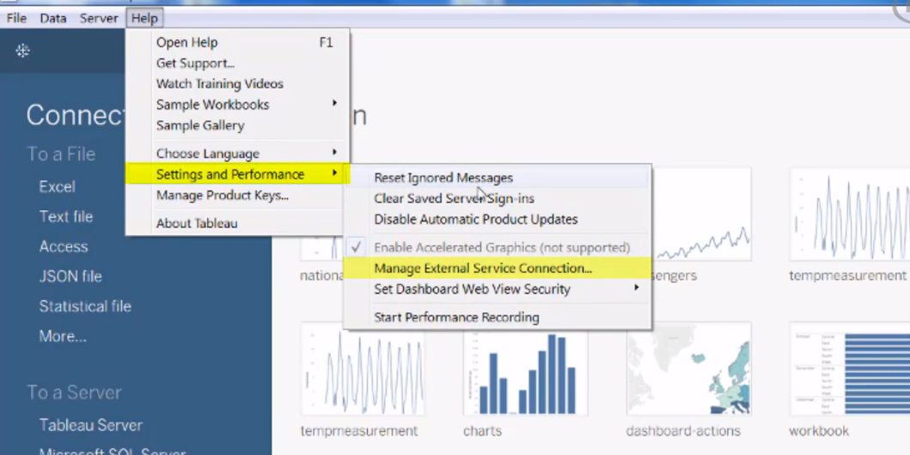

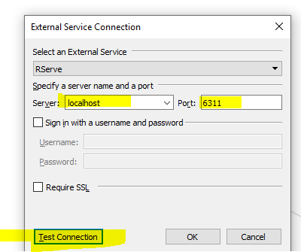

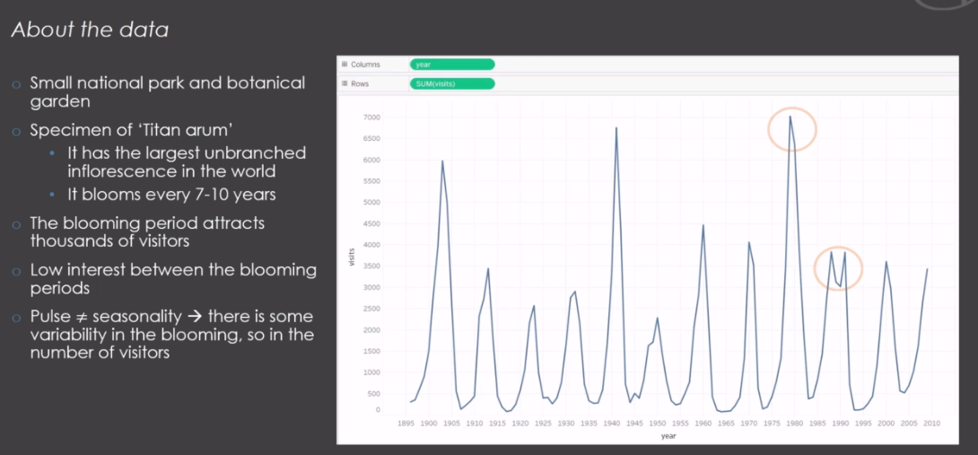

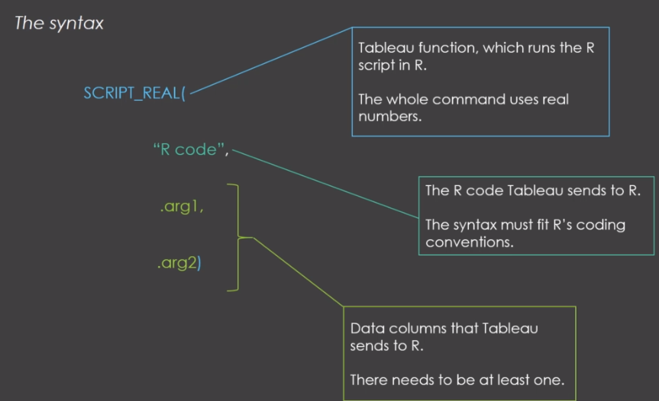

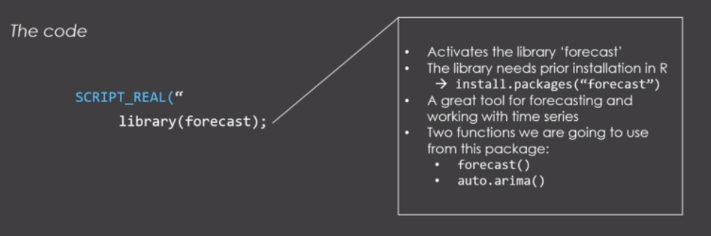

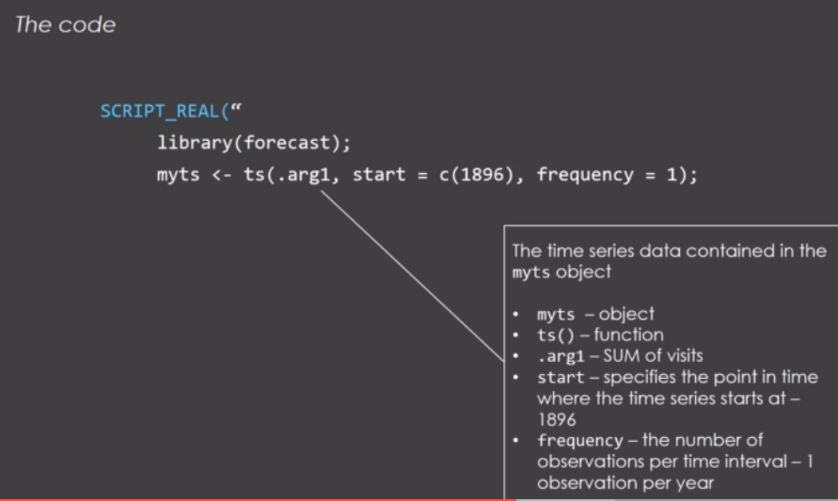

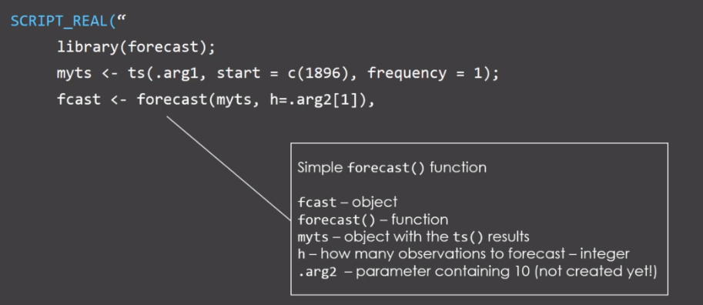

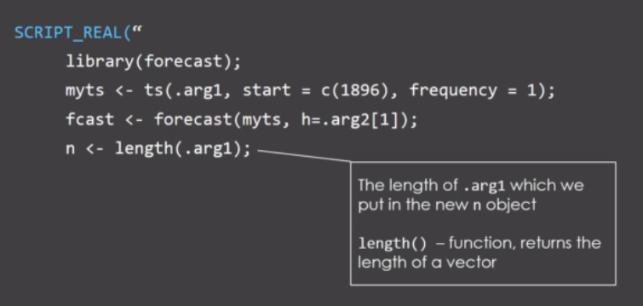

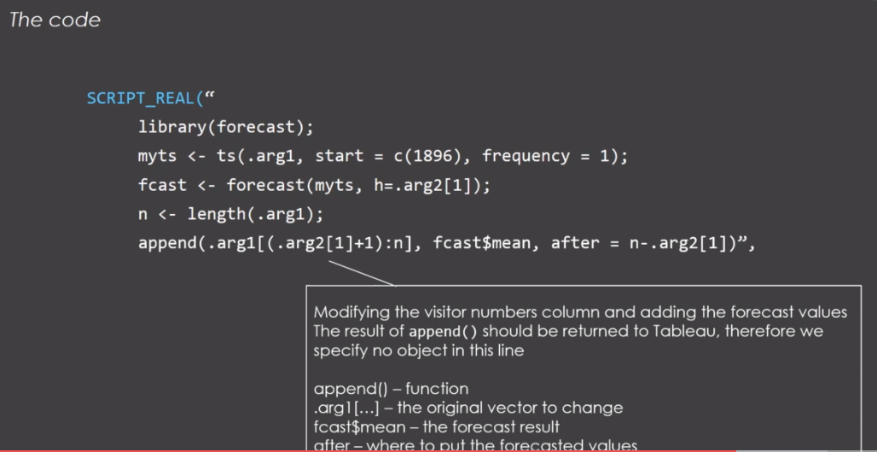

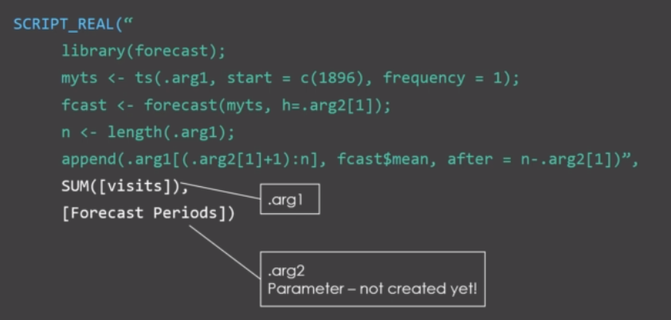

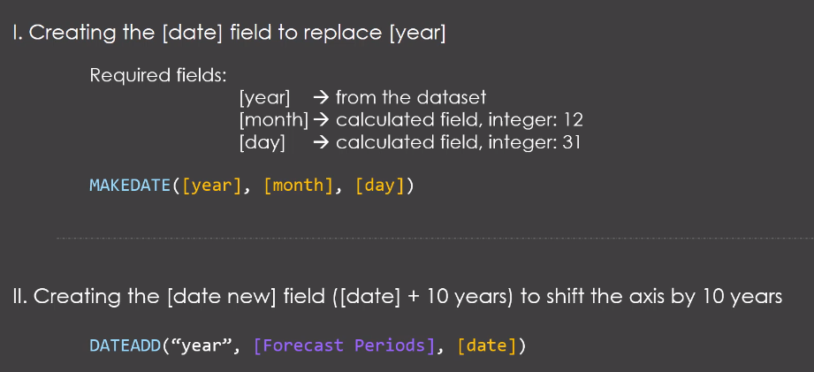

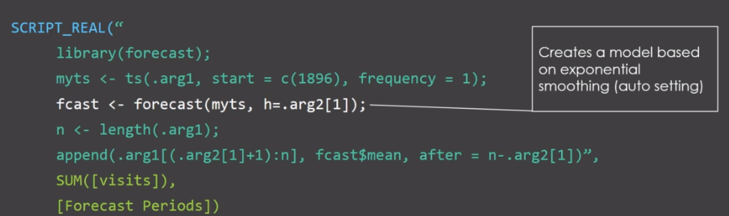

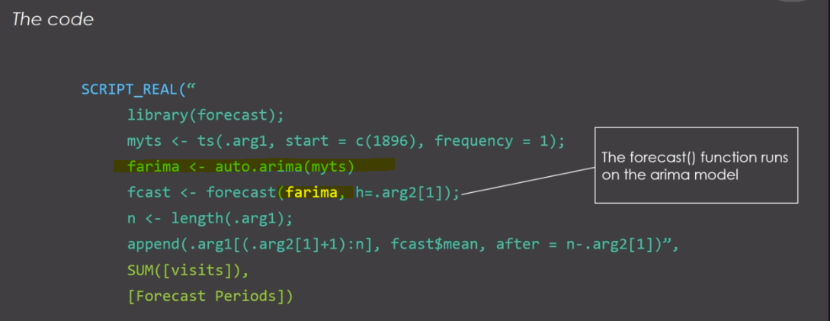

SCRIPT_REAL("

library(forecast);

myts <- ts(.arg1, start = c(1896), frequency = 1);

fcast <- forecast(myts, h=.arg2[1]);

n <- length(.arg1);

append(.arg1[(.arg2[1]+1):n], fcast$mean, after = n-.arg2[1])",

SUM([Visits]),

[Forecast Periods])

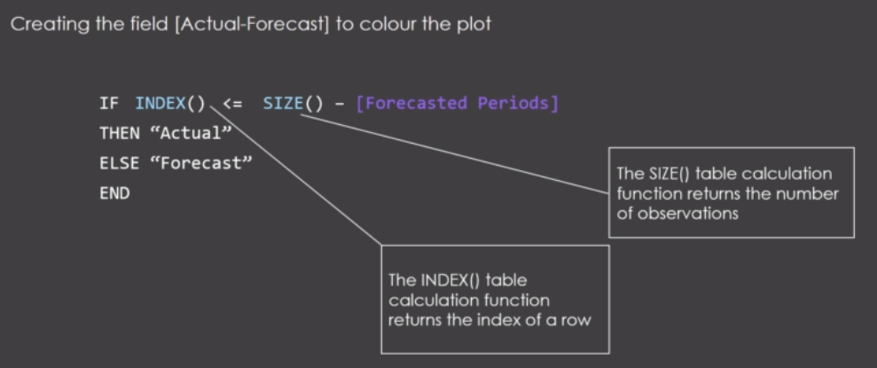

Let's put the result of the forecast in an object called F cast.

We need that name in the code so that we can get access to its content without a name.

It's hard to use it further on in the code.

So f cast is an object that uses the forecast function under previously created object.

My TS from over here and there is a time series with the visitor numbers and we need the argument h

which tells the function how many observations or time Pynes we want to forecast.

And now it gets really interesting.

We could simply indicate say 12 or 10 for 10 observations but that would make it hard to get the correct

now it gets really interesting.

We could simply indicate say 12 or 10 for 10 observations but that would make it hard to get the correct

amount of rows back.

We could probably not use to forecast data into blue therefore we need a work around here so that we

can use the data with the exact length interview where we need to create a parameter indicating how

much data we want to forecast.

And this is going to be the same amount of rows we are going to snip off the beginning of the data set.

So here in the function we can just state that AA Cheechoo and inbox brackets one where we find that

parameter into blue and we would of course put the parameter name at the end of the code so that it

gets sent to our as well.

All right.

So that is how we specify how many forecast fields we want with the age parameter and we set a semicolon

to end this line.

And next we need to extract the number of data in our time series.

This is called the length of this vector.

Let's say we're going to call this N which is dysfunctional length on the first argument.

This simply counts how many observations there are we need this info to get a vector to test the exact

length as the one we send to our.

But this should also contain the newly generated one and in the last line we're going to use the function

append which modifies the visitor number column and adds the forecast values.

That one is actually a bit tricky.

So we will take a close look at it.

First of all we're only using the function we do not create a new object.

So why is that.

Well this time we do not want to use the content within our.

We want the whole content the whole column to be sent to Tablo in order to visualize it.

Their opponent has three arguments which you need to feed into.

First is the data the original vector you want to change.

In this case the dot h g one with the visitor numbers and then you need to add the data which is to

forecast results and then you also need to state where to put the new data with the after argument.

So in detail it looks like this.

We of course need our argument one to visit visitors number but we only need a shorter version of this

one in order to make some free space for the newly created forecast.

We simply want to snip off the first few observations.

The oldest ones which are the least important and we do have this data into blue anyways so we need

to specify in box brackets that we only want the data starting from the observation number we specify

in the number of forecast periods which is our second argument plus one.

And this goes all the way to the end which is the observation number indicated as the length of the

vector or we call it n.

All right so now we have snipped off the first part and this can now be filled with the forecasted values

which is s cast from over here.

But we only want the numbers without any other info.

Therefore we state dollar sign mean we could also extract things like the fitted values of the model

confidence into walls and so on.

But for now we only want to forecast numbers on a forecast period specified here with the age argument

and at last we simply state that we want the new data to be placed at a position starting at the end

of the vector minus the forecast period.

That way we make sure that the hole we created here is now filled with this data and we get the exact

same length as output as it was sent to our.

And that's basically our part.

We can close the brackets and close the quotations to tell Tablo that this is to code to be executed

in our.

Now all we need to do is to specify the data that comes with the code.

We already said that we have two arguments dot.

One and Dot energy Jew.

So what are these arguments.

Well the first one is the sum of visitor numbers.

So we pick that vector in the coat some tails to be loaded.

We want the whole dataset and then we also need a parameter for the perience that parameter we will

set into blue soon.

So for now let's call it forecast periods and put it on the second slot and that is the whole code we

need for our integration.

Now it doesn't actually get us an error message because we still need to set the parameter for the forecast

The below chart is designed to show the monthly highs and lows for crude oil closing value in INR ( Indian Rupees) and everything in-between from 2009 to 2016. This chart communicates much more valuable information than a simple line chart. Therefore, designing of a chart based on the available data is crucial which sometimes is not strait forward.

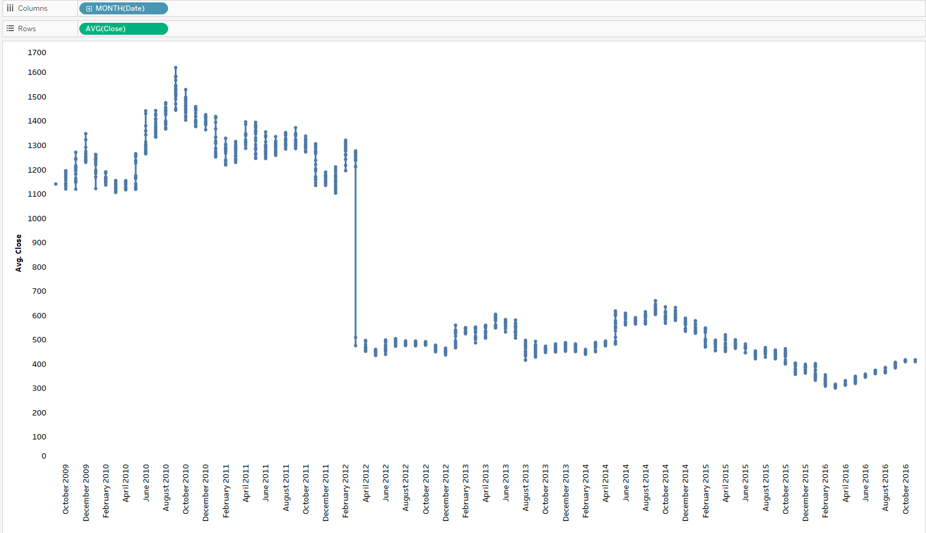

In the below chart, the top part of the chart shows the running sales total for three years by month and the bottom area chart is the difference value against the previous year. The orange area is the difference between 2014 and 2015 and the red area is the difference between 2016 and 2015.

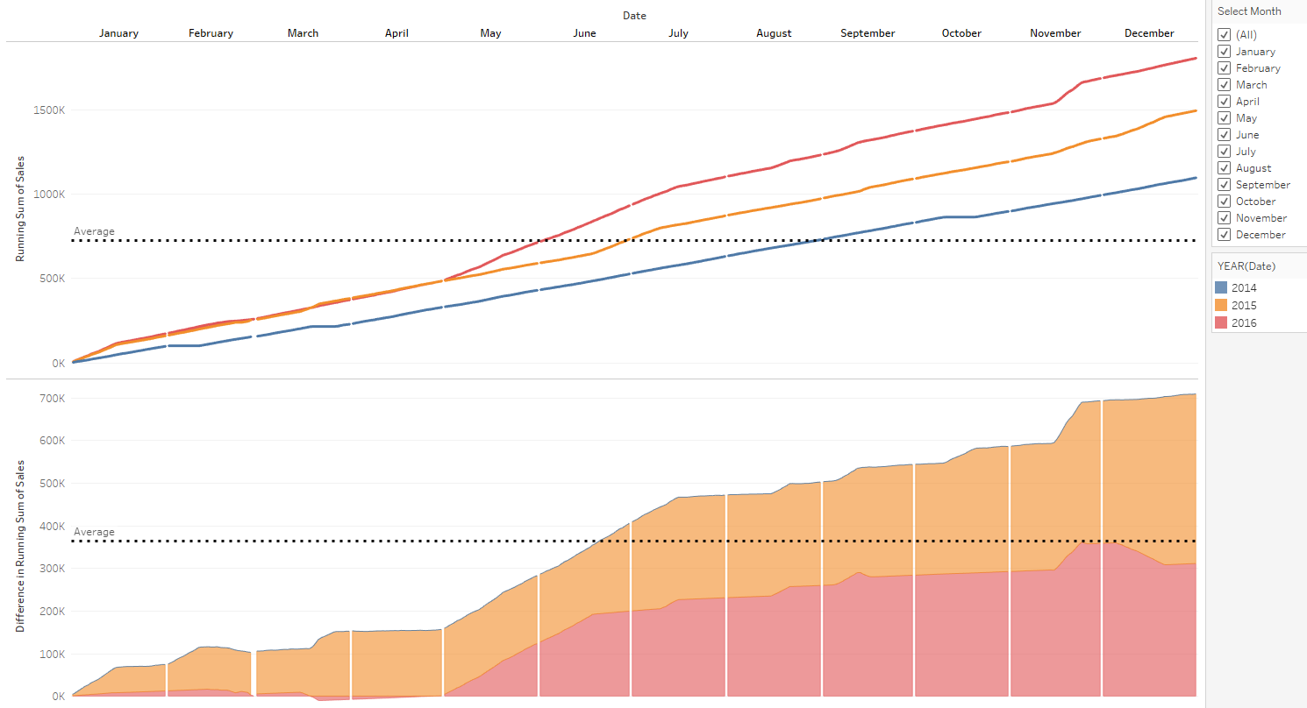

The below chart is the same visualization but we wanted to see the value compute using **pane across** and table calculation **sum** for the primary chart (top visualization) and the bottom part of the area chart, we used compute using **pane across** but the secondarykept **‘Year of date’** for calculating the sales value difference between years.

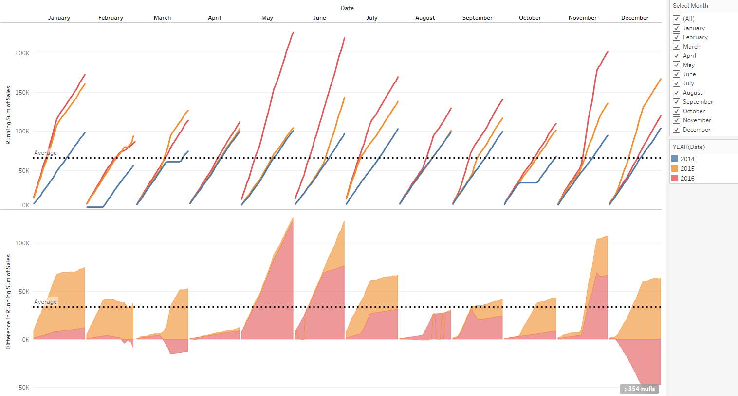

In our below exercise, we wanted to show which customers require follow up phone call based on their latest purchase. First, we filtered out the latest purchase for each customer. Then, applying the DATEDIFF function (the difference between the order month and the latest month), we created parameters for one month, two months and three months. Also, we created the logical function to distinguish customers who need to contact (for an example below, if we chose more than three months on the ‘Vendor to Contact’ parameter to see which customers required to be contacted , the orange bars shows those vendors). The remaining blue bars are below the range of three months; therefore we do not need to contact.

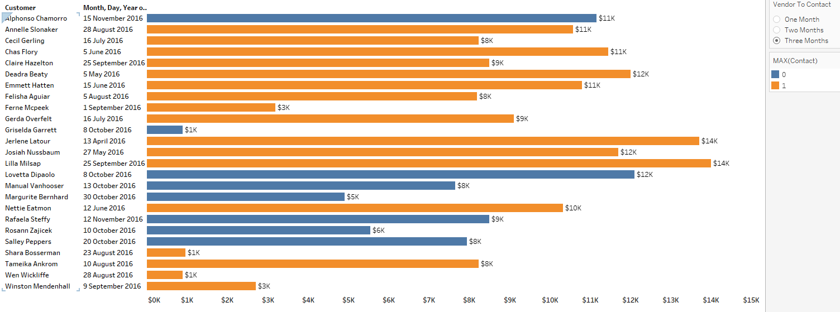

In the below graph chart, we have created parameter control for running total and running average. We have used integers as 0 (Total) or 1(Average) for possible values. This gives a combination chart featuring bars and a line.

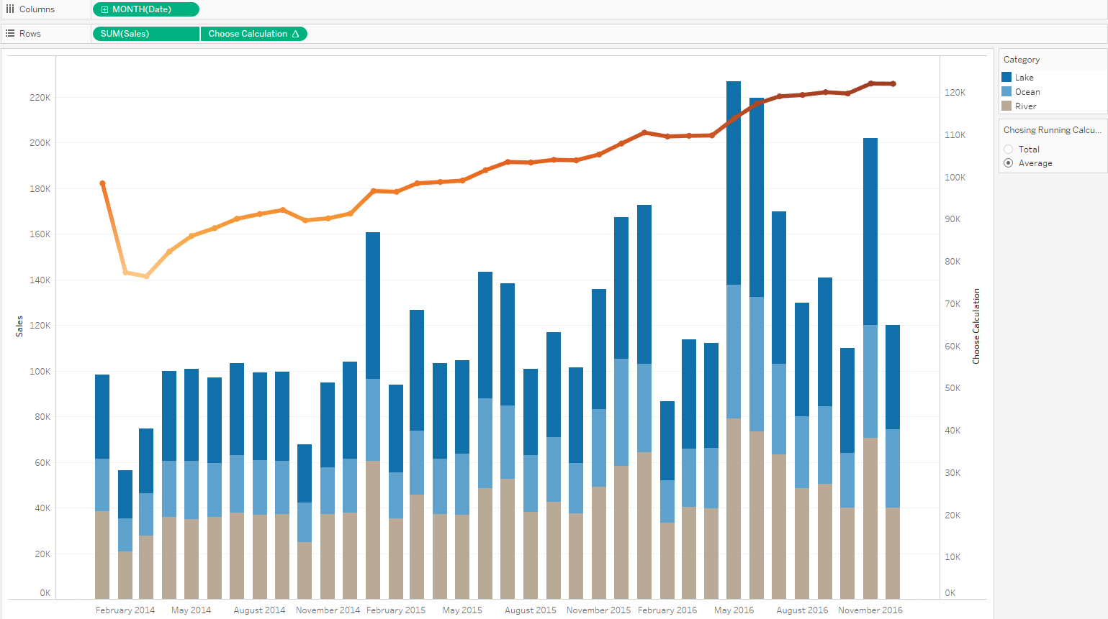

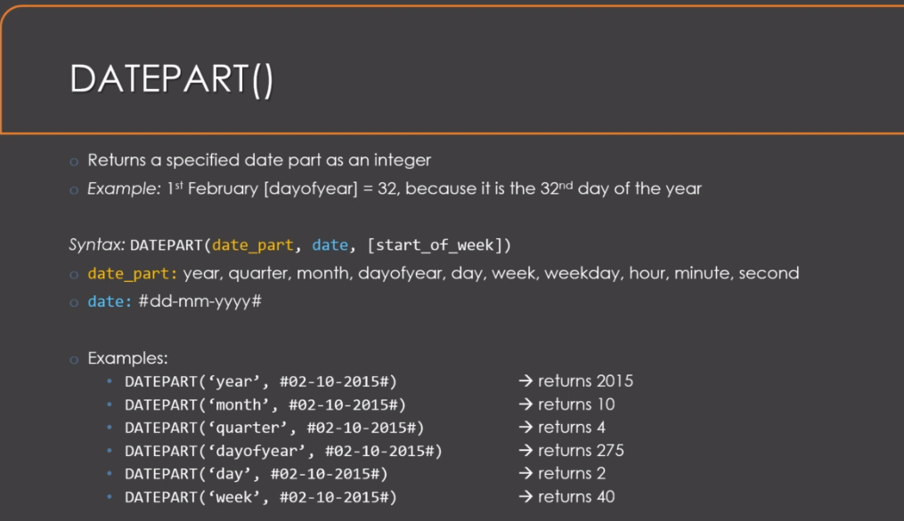

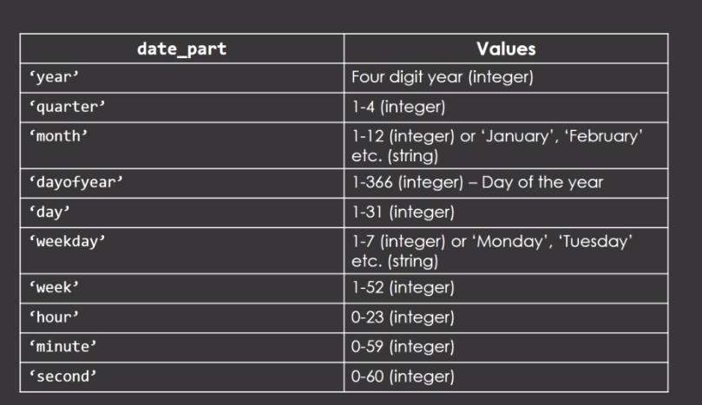

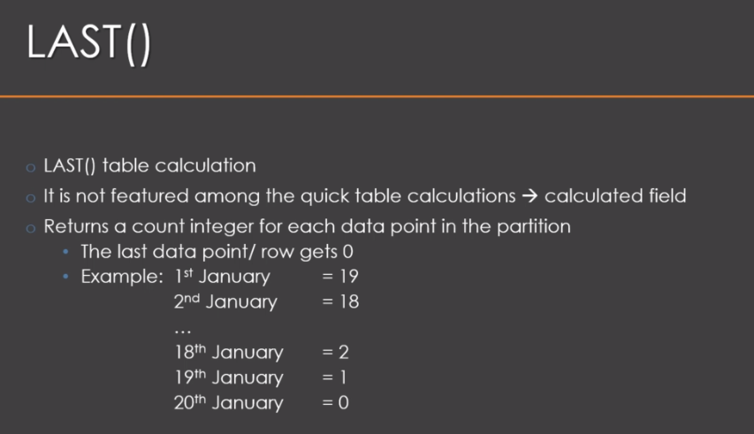

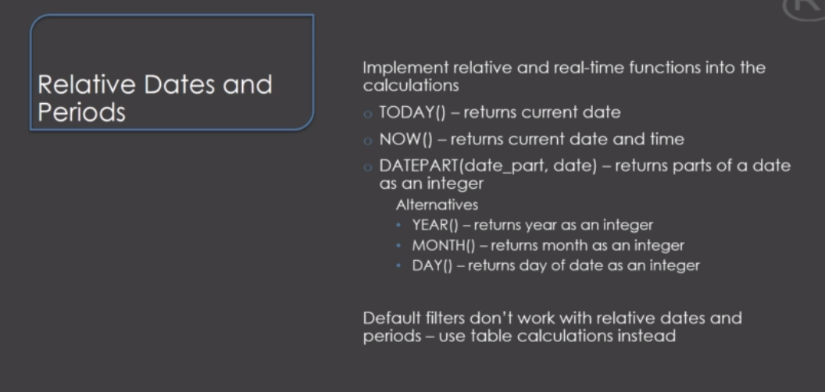

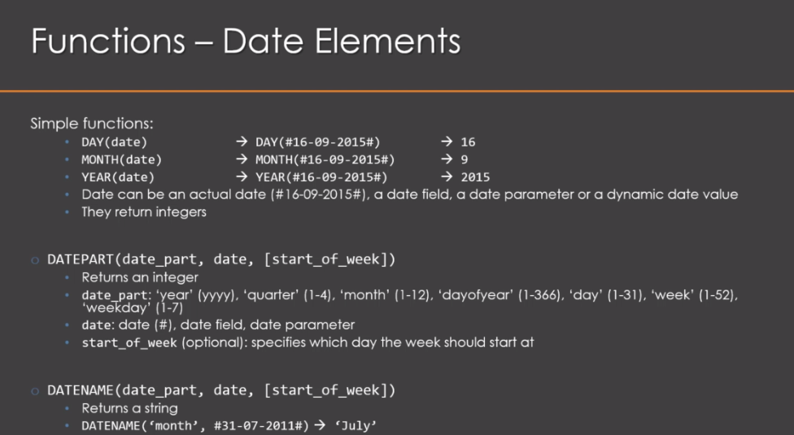

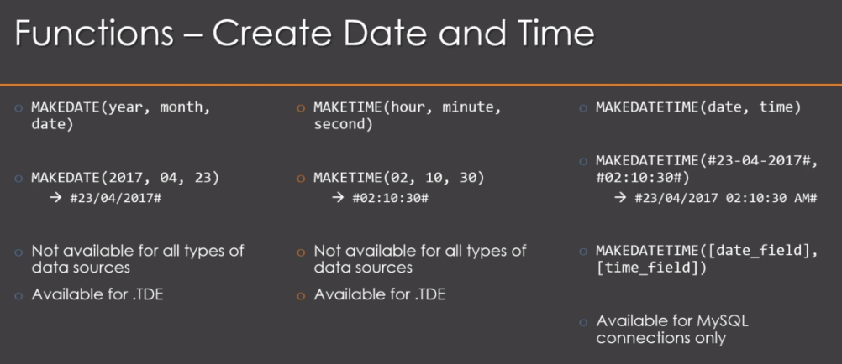

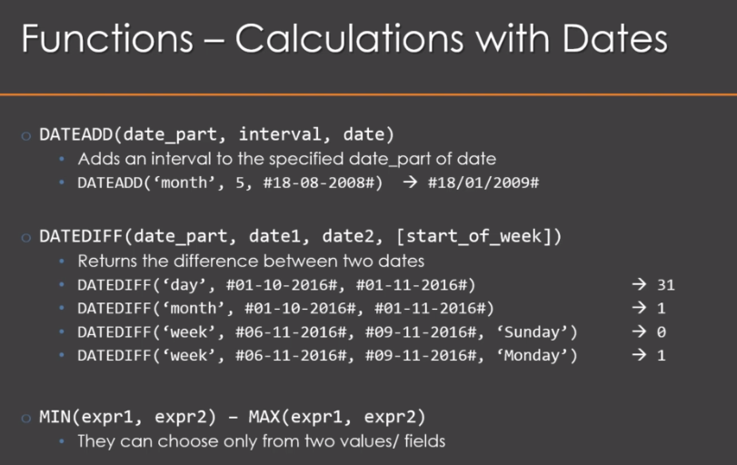

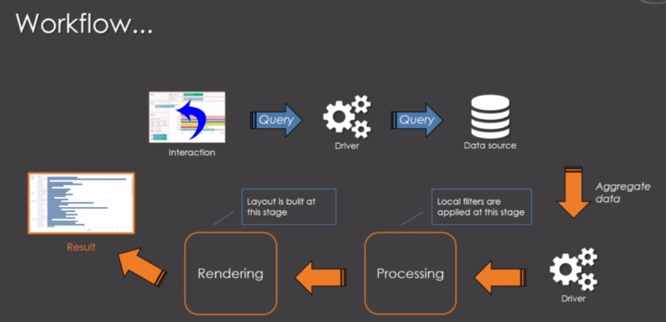

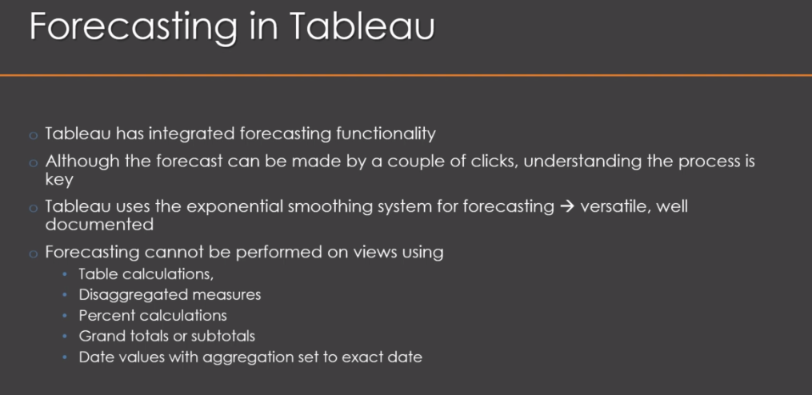

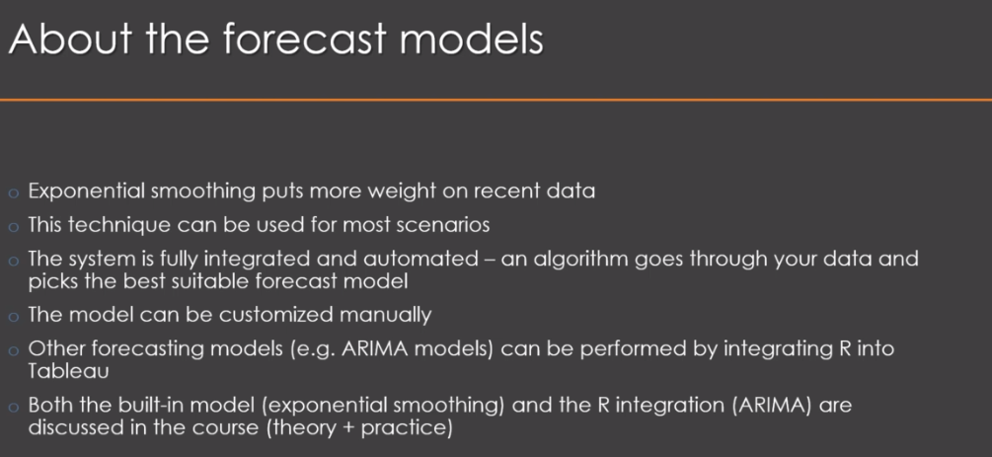

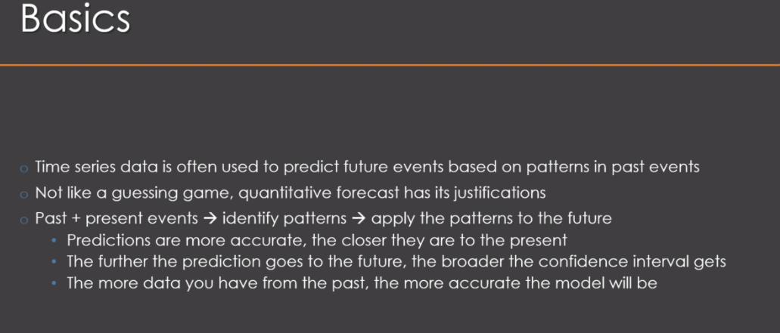

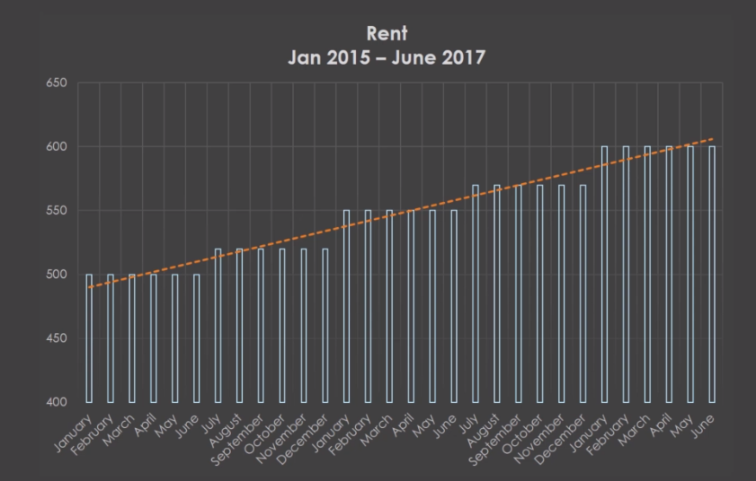

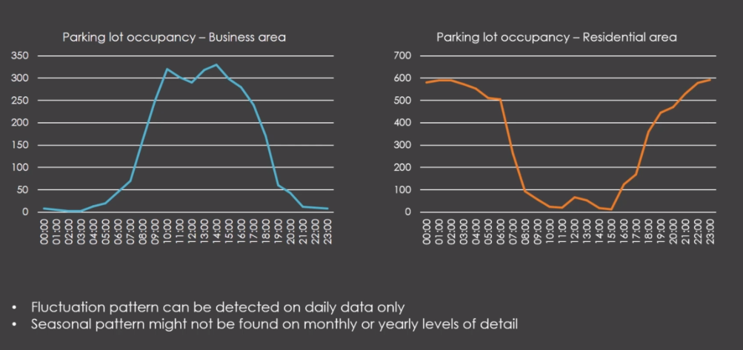

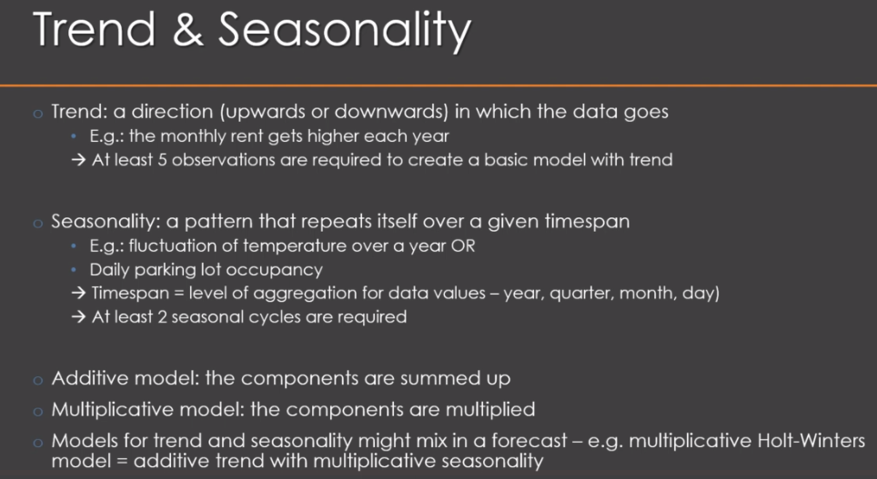

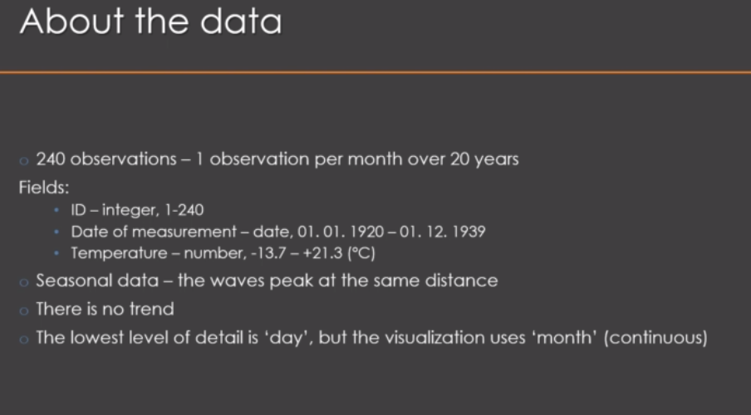

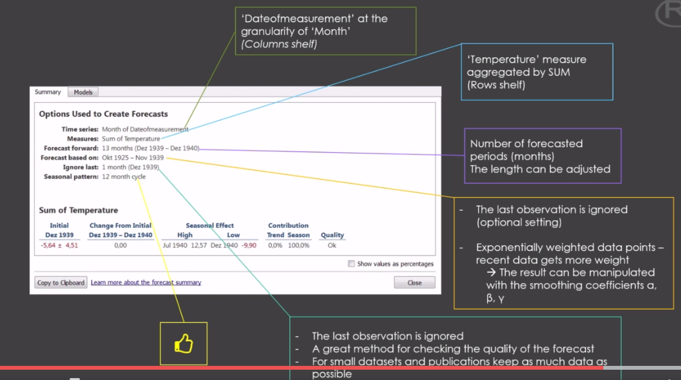

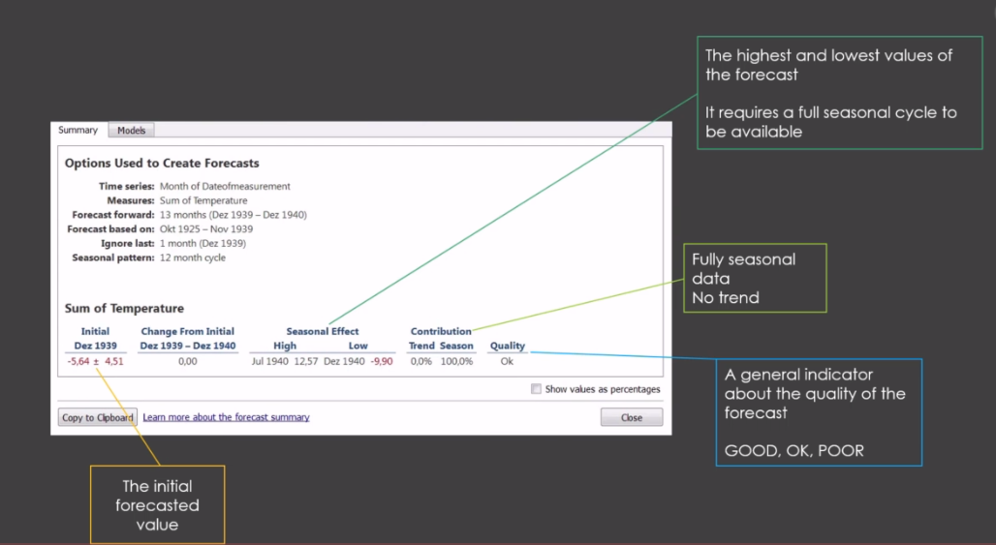



So now we need to set the forecast period barometer to get the code going right click in the measurers

area and create parameter.

Now the most important thing is to name this parameter the same way as we indicated in the our script.

So for this example it should be for cost periods.

All right.

That's very important since it validates our our script.

This parameter is going to be an integer.

And let's say we want ten periods or 10 years to be forecasted.

So we're going to state 10 Here is our current value.

The cool thing is that we can easily change this just by editing the parameter.

And that's basically it.

That is how we specify how many observations we want to forecast with our script.

All right.

So let's click OK and let's see what we can get with this

so we can now put the forecast from our on the rocks shelf to get a double plot.

All right if we check out the plot we can see that there are indeed some values at the right end of

the plot that are new ones which is a good sign but it is just a flat line which indicates that we have

a simple last observation carried forward system and that is something we need to fix in the coach.

But before we do this we can see that there is something wrong with the data access.

There is no shift the access stayed the same while we moved the values to the right.

For 10 years.

So how do we fix this.

Well we need to get a calculated field for the whole axis and this is going to be a date access with

the years of the observation and the forecast.

But so far away your data is a simple integer and there is not going to work with a calculated field

based on dates.

Therefore we need to fix this first.

There are several ways in how to get this year into each of them took it into a date.

We will use the make Date function in the calculated field the date will have a year and month and a

day.

So now that we have the yearly count of visitors of the National Park I would simply use the last a

day of each year as the date of the count.

So we always need 12 month for December and we need 31 as the last day of this month.

Therefore we are creating two calculated fields.

The first is called month and it simply has a twelth in it.

The other one is called day and it has a 31 in it.

So that is really simple.

And now we take these fields and put it in a new calculated field which we're going to call a date.

We will use the make Date function for this one and we're using the argument you're the one in the initial

dataset.

This argument will determine the length of this vector and then we are also adding month end day which

will fill the empty fields by recycling.

That means they will repeat themselves for each year and that's basically it.

We can press OK to get a date for further processing.

All right so now that we have the date for our x axis we can create the date with the actual shifted

dates.

So we create a calculated field and let's call it a date new and we are going to use the function date

and for that.

Now here we need to specify three arguments at first we are stating here under quotations since this

is going to be yearly data even if we artificially scaled it down to a daily level Next we need to state

how many years we want to add and which ones this is set with our parameter forecast periods so we put

this barometer in here and the last we're going to state the name of the underlying date data which

is the date field which just made out of our original year integer.

And that's actually it should do the trick to adjust the data for our X-axis.

Let's try it by cleaning the X-axis which is the column shelf.

And but inserting the date new shifted to date in here makes sure that you use this field with a continuous

data roll the date values should be year.

And indeed as we can see.

Now the chart goes 10 years into the future and the first 10 years on the left side were deleted like

it should be.

So with this adjusted date we basically moved the whole x axis the date 10 years to the right.

Ten years what's the value for the parameter forecast periods.

So that is fine.

We fixed the issue with the time axis but the whole thing is still not really satisfactory.

There should be some color indicator of the forecast points.

The audience needs to be able to differentiate between forecasts and actual values.

And we also want to try an alternative model.

This turns out to be just a simple last observation carried forward model without seasonality which

should be improved.

So let's fix the model issue.

At first we use the same calculated field as before but we will modify the code so that we get an Arema

model there for just right click on the calculated field and select added.

It's actually just one simple line of code which will change the model to AREMA.

Let me explain why this is possible.

We have to forecast line or here that line takes the data.

In our case the visitor numbers and gets the number of forecasts specified here with the H parameter.

So Fosler good.

That is the basic setup.

Now we have to know that this forecast function creates a model based on exponential smoothing.

If nothing else is specified in other words exponential smoothing is the auto setting which can be altered

if we alter the code as well.

So how do we do this.

Well we just need to create a model and then we can incorporate the model into this line.

That means we will add an extra line here.

Let's call this object F..

Arema and this one uses the auto dot Arema function on the time object from over here called mine.

The auto data Arema function is extremely helpful since it checks the data and selects the best Arema

parameters for your data.

Very easy and very powerful.

And now we need to take this object which we called F Arema and we need to put it in here instead of

the previous data.

Now the forecast function runs on this Arema model and we will no longer get an exponential smoothing

which in this case even results in a last observation carried forward the rest stays the same.

Which means it's even very easy to test several models.

You can either change the code in here and edit the calculated field you initially created or you can

copy and paste this one and get a new calculated field.

All right so let's press OK and let's see what we get.

Now this model as we can see here in the forecast area takes at least some consideration of the pseudo

seasonality or paths we have in our data.

Keep in mind that this dataset is a tough one to forecast and to model the seasonal pulses vary slightly.

We have the triple event here and the distances between the peaks are not always exactly the same and

the peak observations vary considerably.

All of this makes it hard to be accurate but I would say that this limited pulse is a valid alternative

to the model that we saw so far.

So now that we have found an Arema model which takes into account that there exists some seasonal pass

as well.

We need to work on the visualization.

So far we cannot really see which part consists of actual data and which part is forecasted to fix that.

We need you gasted a calculated field.

So let's right click here create a calculated field and this one is going to be a simple if statement.

So how do we set it up.

If then we need the index.

The index is basically the internal ID of an observation or a row.

Each row has a number.

The last observation which is the last forecast that value has the highest index.

So if this index is smaller than or equal to the size minus the number of forecasted periods that's

the parameter then it should be called X sure.

Alice we wanted to be called for cost and we ended with the end command the size here is the number

of observations.

It's the same thing as the length in our in this case including the forecasts we have for size of 124.

If you subtract the number of forecasts we are in the area with the original data.

Otherwise we have to forecast the data.

All right so let's click OK and let's see what we get here in the few.

Now we need to tell to blue to use this new calculated field to color our chart in order to differentiate

between forecasts and actual values.

Thanks to two blow.

This is really easy.

After all that is exactly what it was made for.

So let's scrap this new field and simply put it over here under color in the Mock's shelf and that's

it.

Now we can see that the last 10 observations are forecasts.